Carlos Mariscal

Cameron Tribe

ECE 532

**Intro**

Stability characterization is performed for the PHEMT transistor (SAV-541+). Simultaneous conjugate matching (SCM) is explored. Stability circles are simulated at 2.4 GHz and a resistor network is used to unconditionally stabilize the transistor.

**Simultaneous conjugate matching**

When a transistor is unconditionally stable SCM may be implemented. A transistor may be only unconditionally stable in certain operating frequencies. In order to find these frequencies a frequency sweep is perform in ADS given an S2P file (see in references). Stability may be determined by the following equations:

$$k=\frac{{1-\left|S_{11}\right|}^{2}-{\left|S_{22}\right|}^{2}+{\left|Δ\right|}^{2}}{2\left|S_{12}S_{21}\right|}>1$$

$$\left|Δ\right|=\left|S_{11}S_{22}-S_{12}S_{21}\right|<1$$

A plot of k and delta is constructed with the S2P file provided by the manufacturer as shown in Figure 1. The arbitrary frequency of 5GHz is chosen for further SCM analysis.

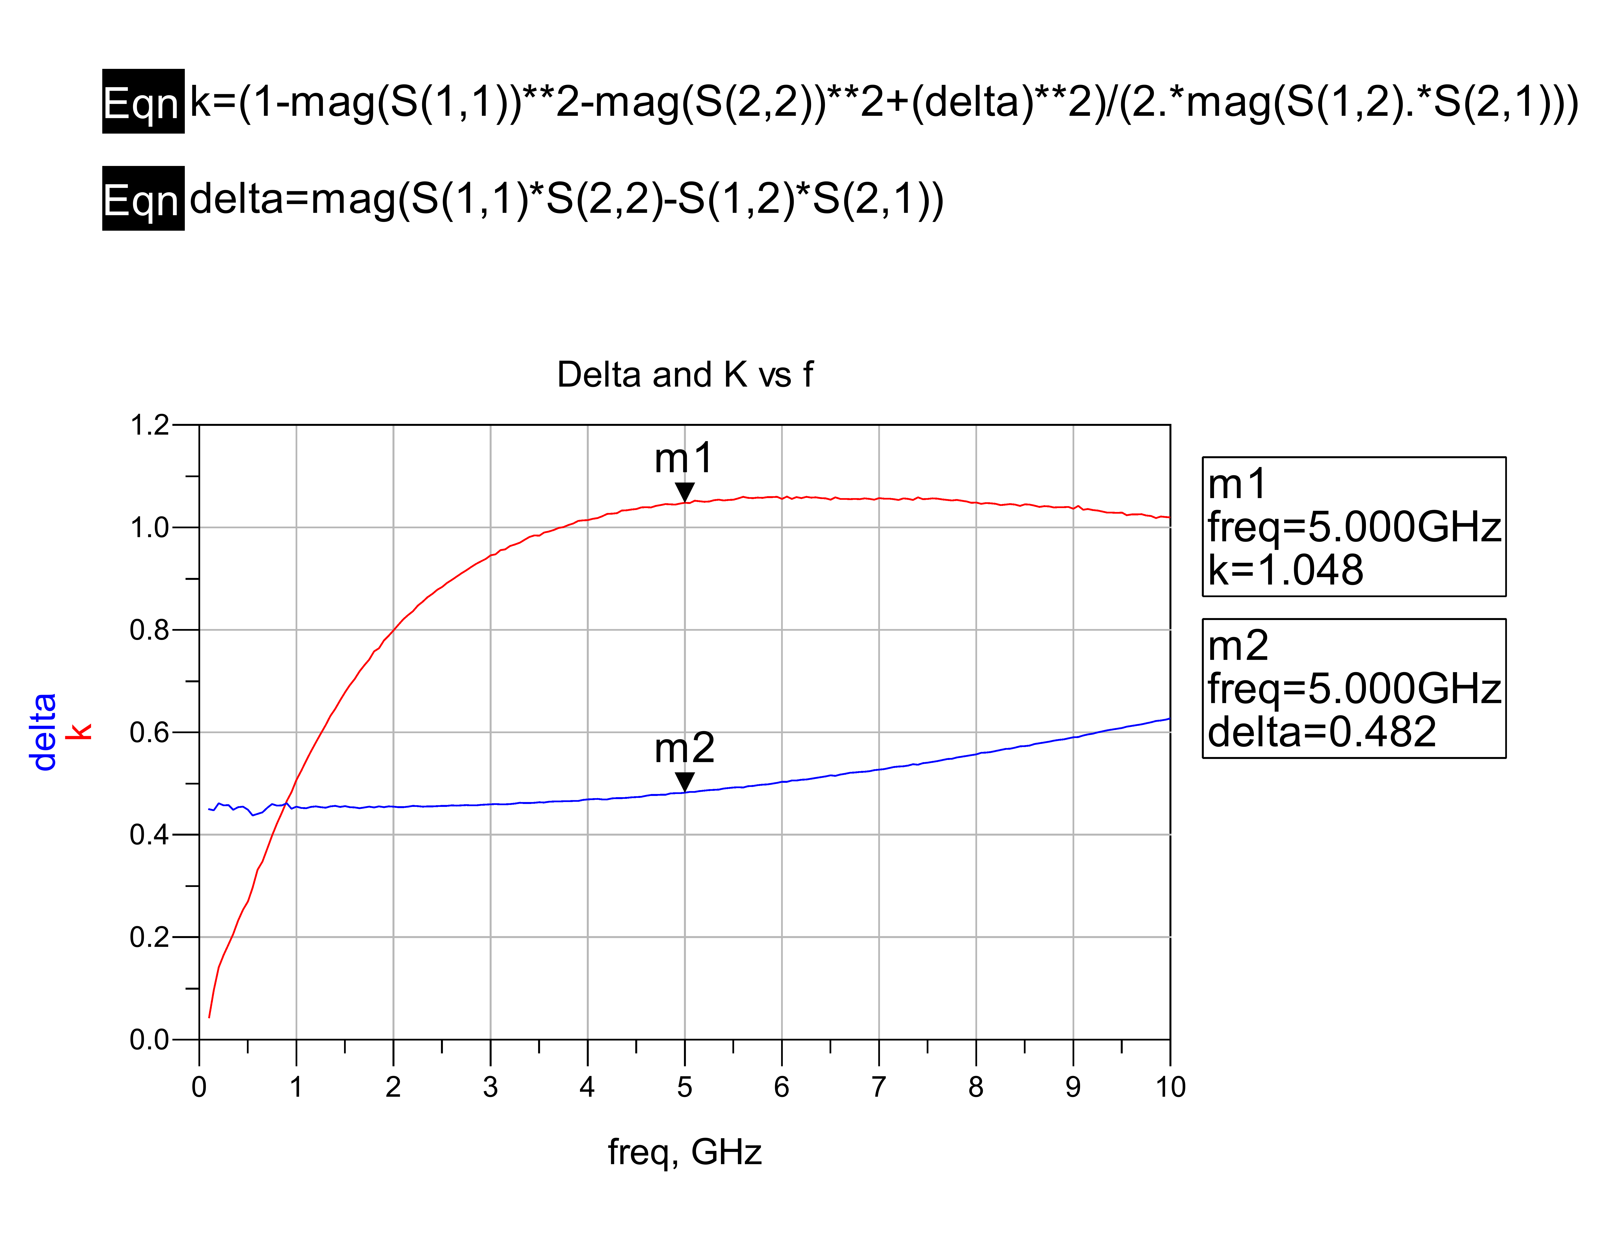

Figure k and delta

Using ADS and the Smith chart tool a SCM network is constructed using ideal micro strip transmissions lines. The matching network schematic is shown in Figure 2 along with the S11 and S22 plots. As seen on Figure 3 the matching network provides an almost prefect match. A SCM match provides maximum power transfer.

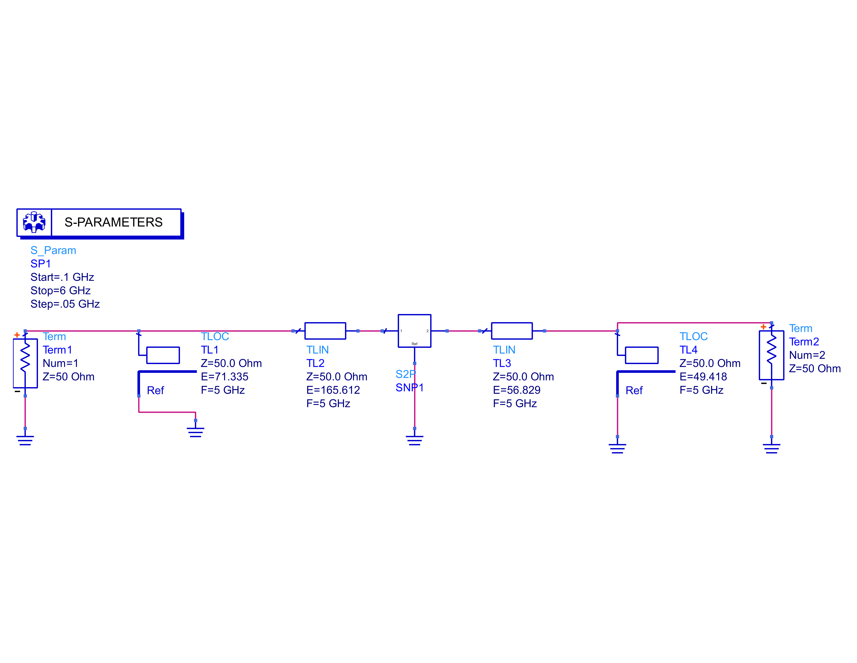

Figure SCM schematic

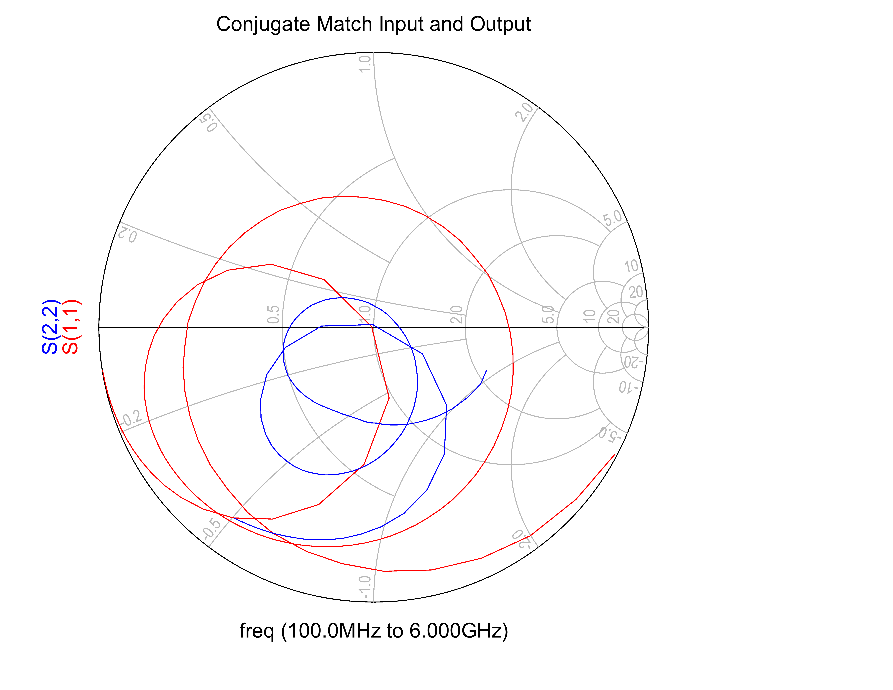

Figure S11 and S22 of SCM network

With the matching network a comparison of power gain is made between the SCM circuit and the transistor without any matching network terminated with 50 Ohms. Figure 4 shows the power gain of both circuits.

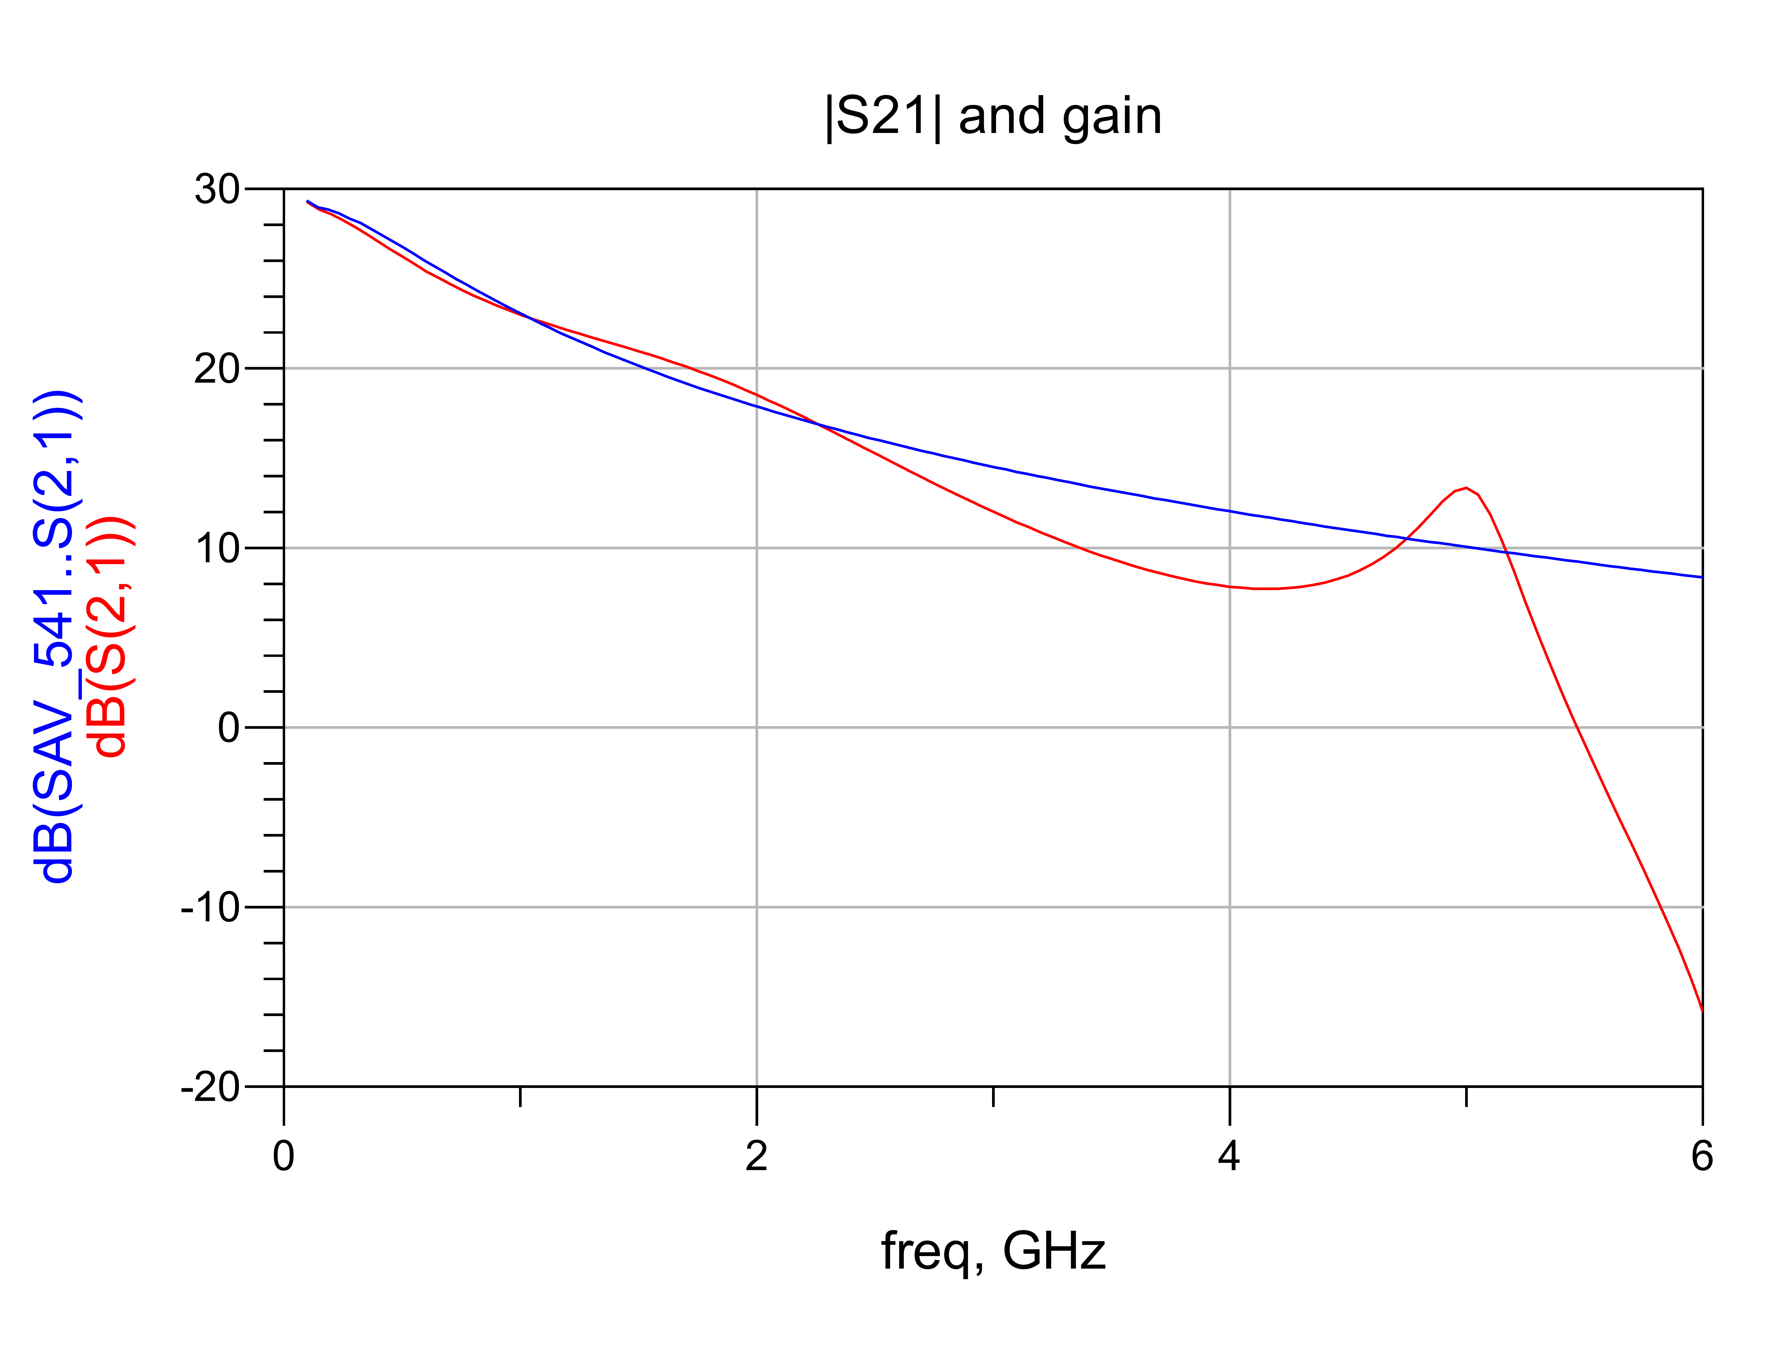

Figure intrinsic gain and SCM match gain

Since SCM match guarantees maximum power transfer and the circuit is ideal (no losses) the gain of the transistor is increased by ~ 4dB @ 5GHz.

**Stability circles**

In order to determine the region in which a transistor is stable, stability circles can be plotted on the Smith chart. The stability is dependent on the operating frequency and input/load impedance.

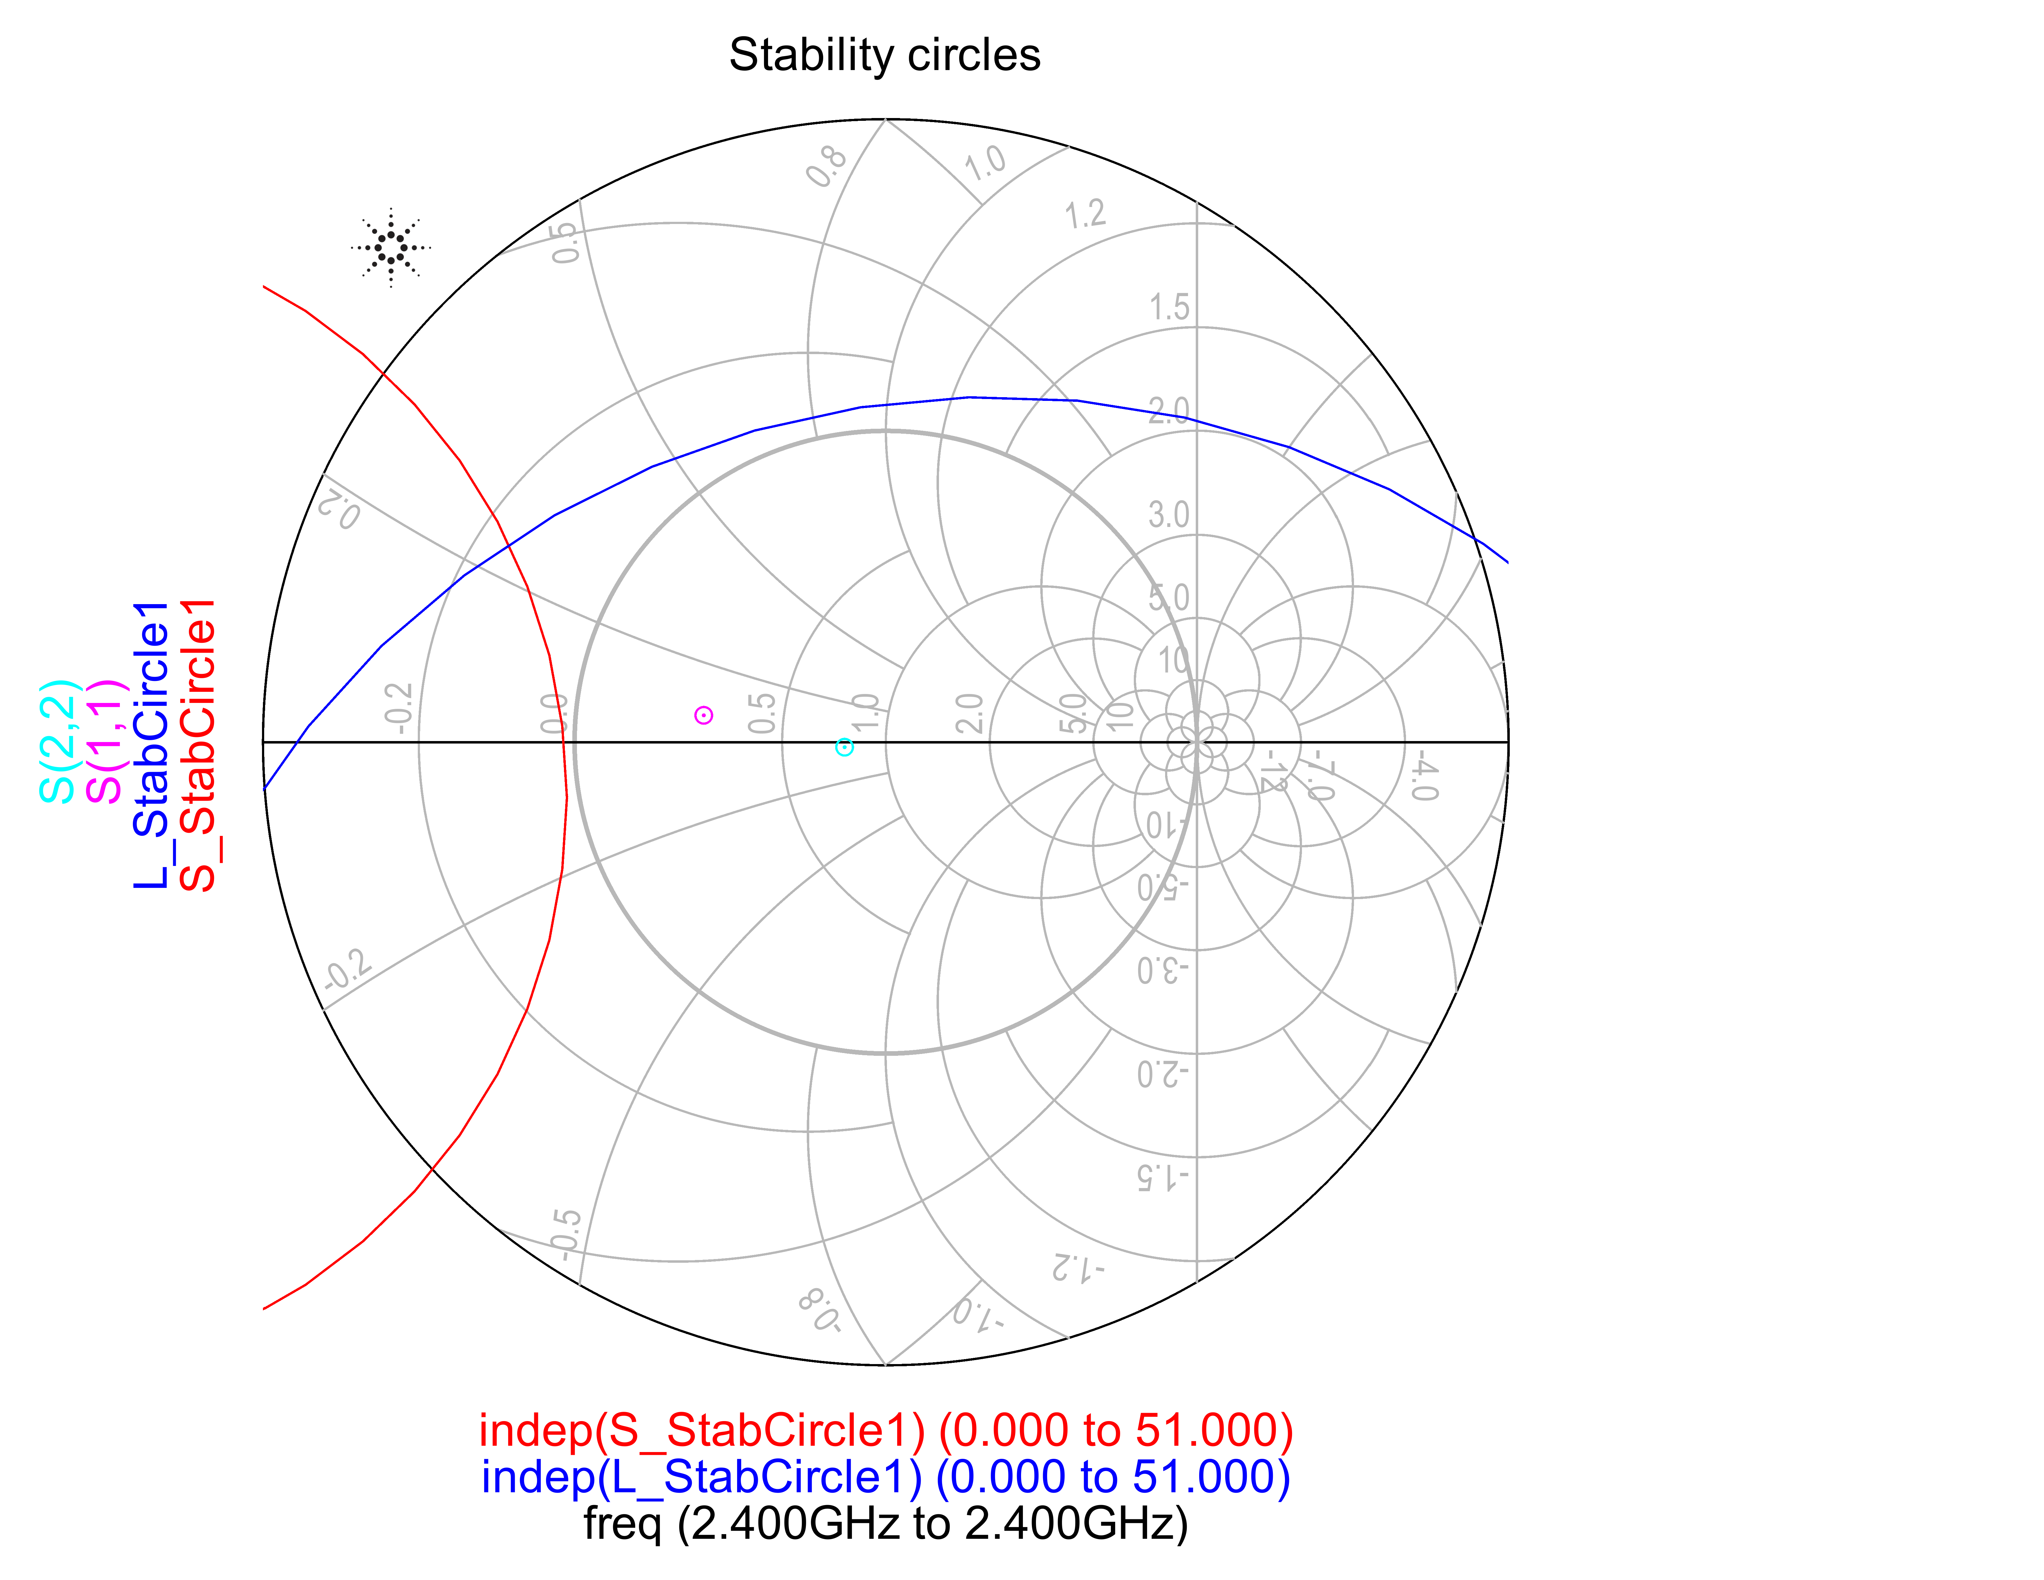

Figure Unconditionally stable transistor

A transistor with a 50-Ohm source impedance and load termination may not be unconditionally stable. In order to make the transistor unconditionally stable resistors may be added in series or shunt to gate and drain. With ADS the input and output stability circles may be plotted. Using the tuning feature resistor values may be tuned to move the stability circles and make the transistor unconditionally stable.

As shown in Figure 5 the transistor was made unconditionally stable by moving the stability circles in such a way the load and source impedances may not cause instability. As seen S11 and S22 are less than unity in this configuration. Using this technique to achieve unconditional stability lowers the gain of the device since some power is now being dissipated on the resistors. The gain in this circuit was reduced by about ~2dB as shown in Figure 6.

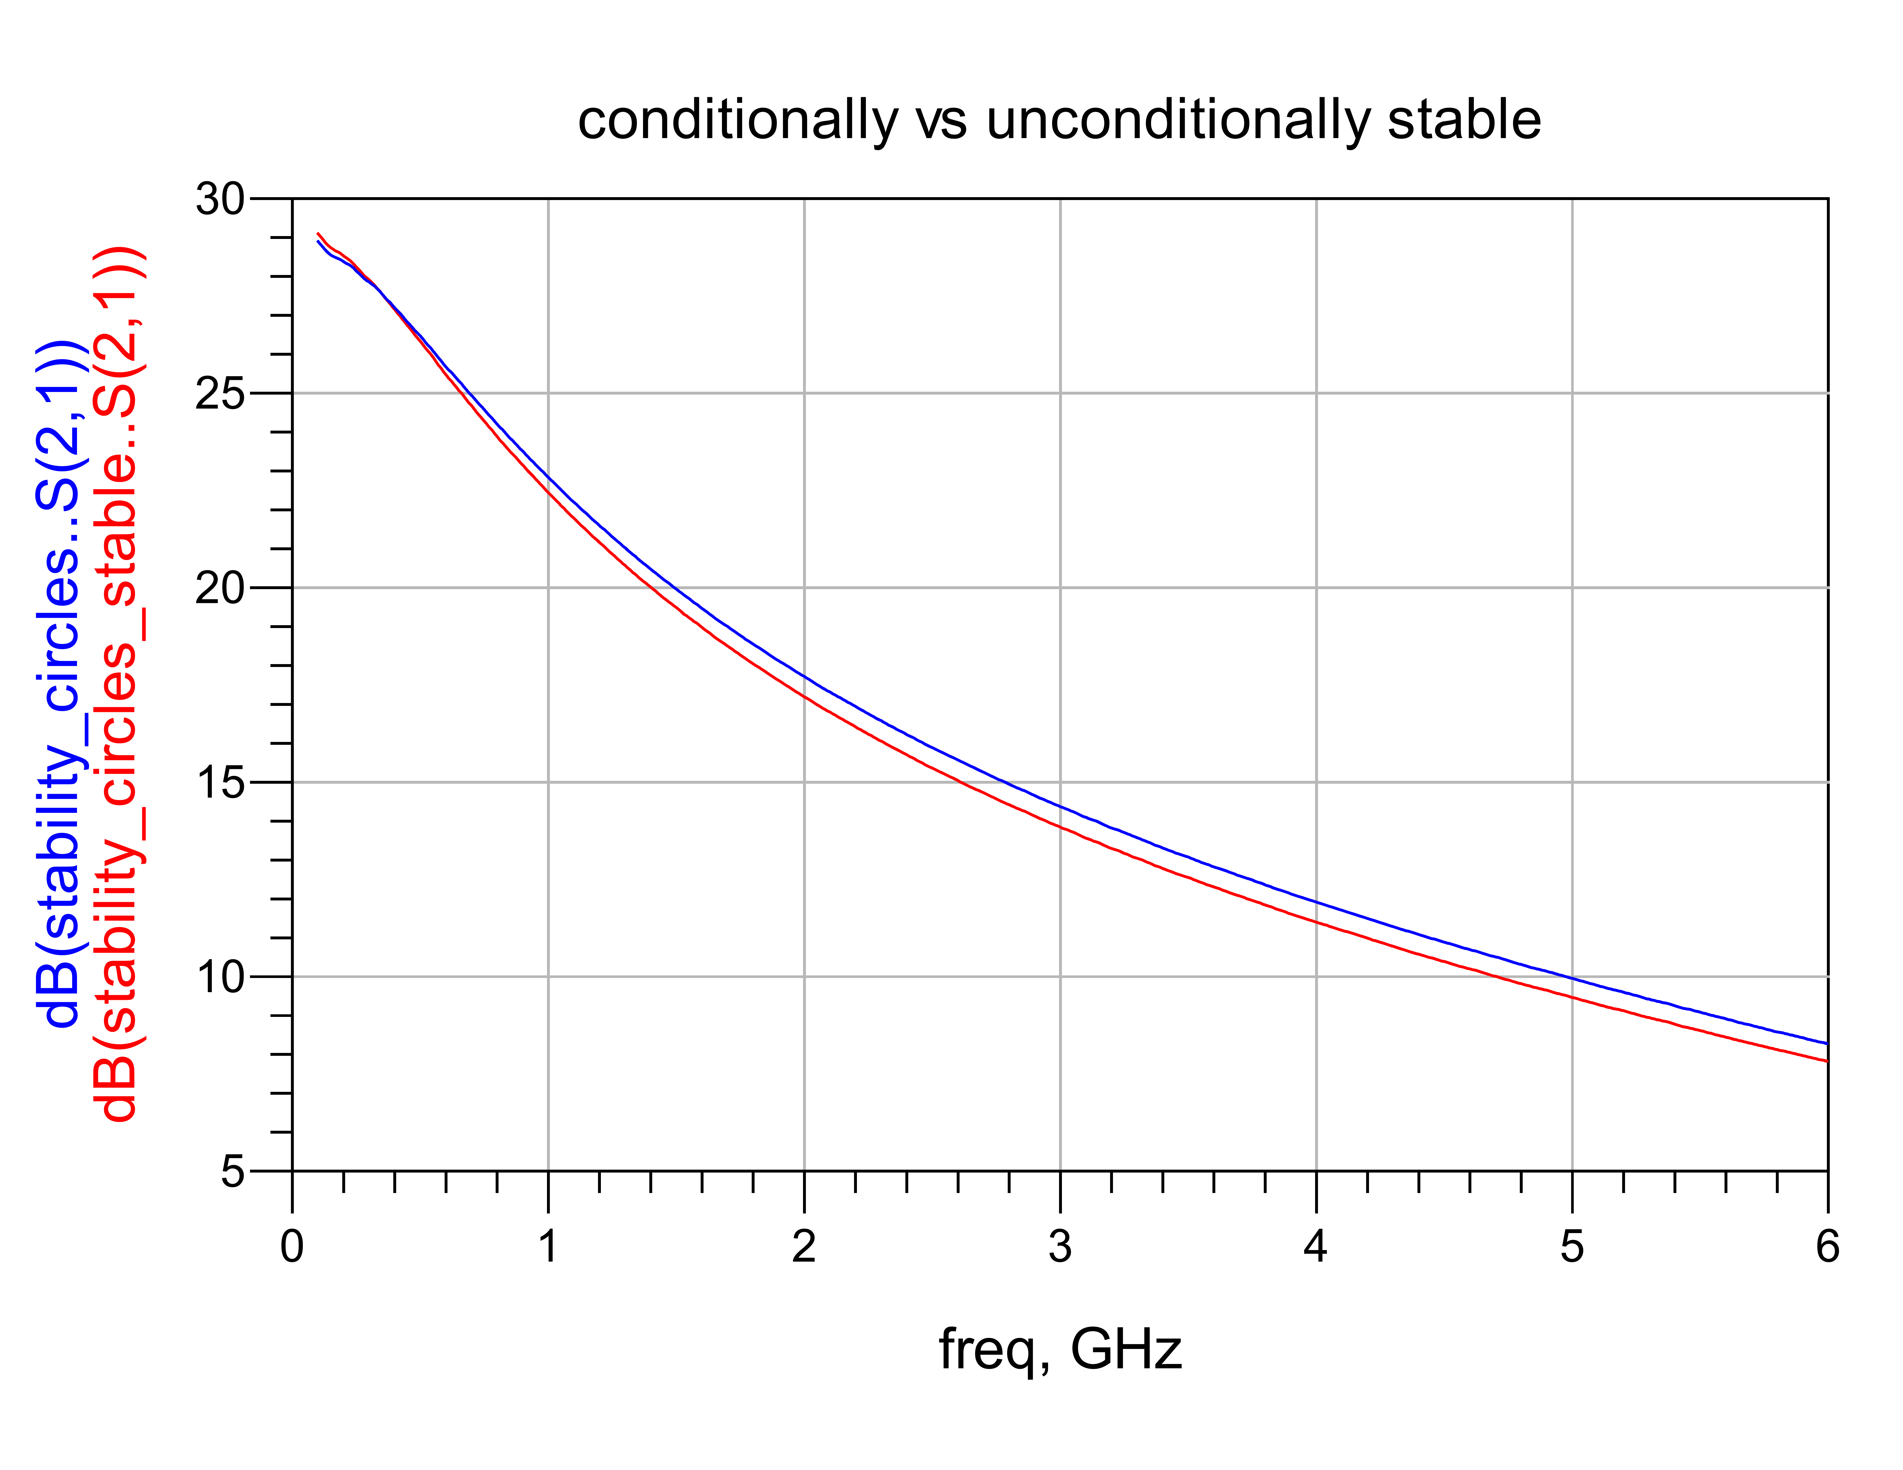

Figure gain comparison

**Stub Matching**

Single stub matching is a useful technique because any impedance can be transform to any other impedance with two transmission lines. In this exercise a reflection coefficient of in = 0.644/172 is transformed to 34 Ohms. For part 1 of the exercise ideal TL are used. Since substrate information is not necessary the TL will be described with electrical lengths. For both exercises the Smith chart tool has used (extra credit ☺).

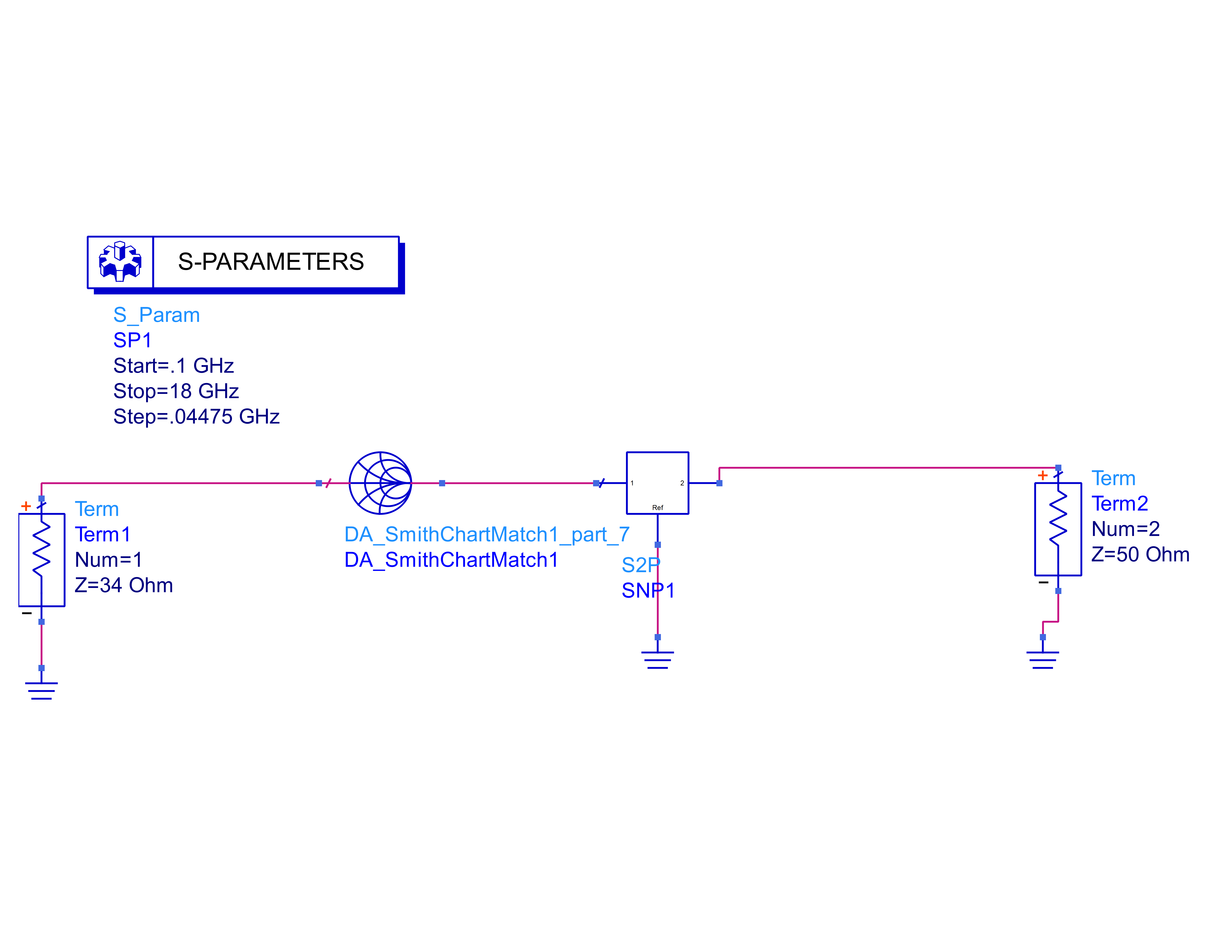

Figure ideal TL matching network

Using the Smith chart tool a single stub matching network the input impedance was transformed to 34 Ohms. As seen on figure 8 the reflection coefficient is ~0.

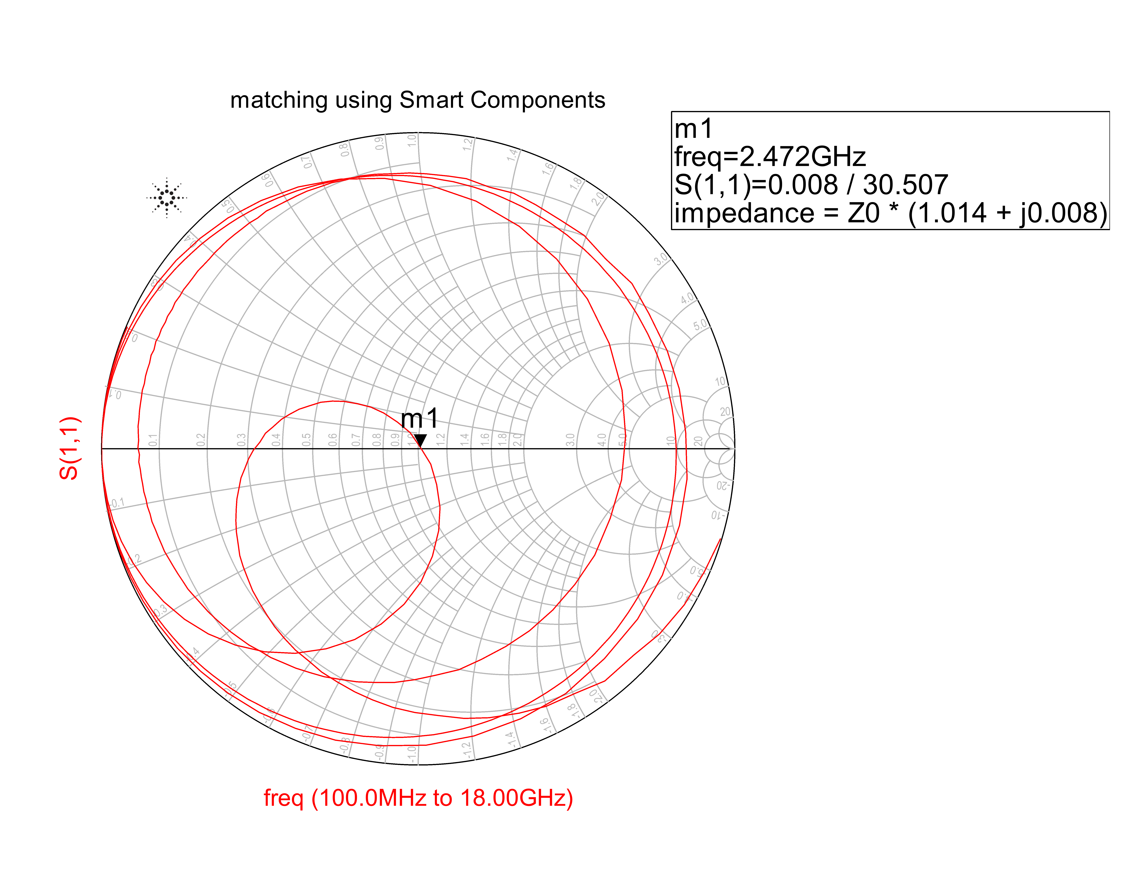

Figure S11 of ideal matching network

In order to realize this circuit with actual transmission lines physical dimensions are necessary. Using the Smith chart tool (see screen shots in references) and the LineCalc tool TL were synthesized. As shown in Figure 9 the physical dimensions of the TL are shown.

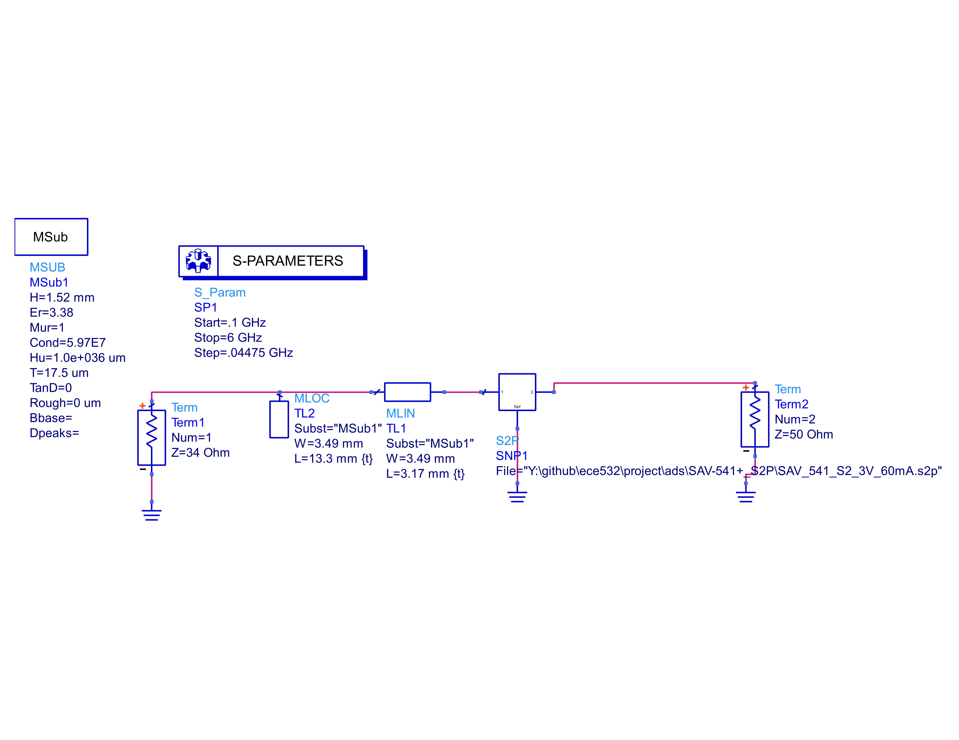

Figure matching network

Figure 10 shows S11 of the above schematic. As shown the input reflection coefficient is ~0 indicating a perfect match.

**New knowledge**

This week involved activities with software only. It was very useful to learn some of the more advanced features of ADS. I found the Smith chart tool very useful and convenient, although I still like to do these problems by hand.

**References**

Files from manufacturer

SAV_541_S2_2V_80mA.s2p

SAV_541_S2_3V_60mA.s2p

|  |
| --- |
| Microwave transistor amplifiers (2nd ed.): analysis and design by Guillermo Gonzales |
| Prentice-Hall, Inc. Upper Saddle River, NJ, USA ©1996 |

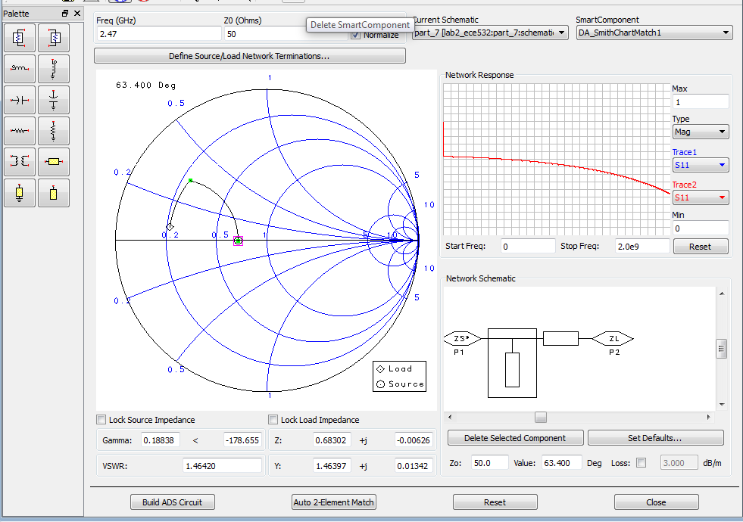

Figure Smith chart tool (for reference only)